// Write a Program to Implicit And Explicit Keyword

using System;

using System.Collections.Generic;

using System.Linq;

using System.Text;

using System.Threading.Tasks;

namespace _10.Implicit_Explicit_keyword

{

class machine

{

public int _value;

public static implicit operator widget(machine m)

{

widget w=new widget();

w._value=m._value*2;

return w;

}

}

class widget

{

public int _value;

public static implicit operator machine(widget w)

{

machine m=new machine();

m._value=w._value/2;

return m;

}

}

class Program

{

static void Main(string[] args)

{

machine m = new machine();

m._value = 5;

Console.WriteLine(m._value);

widget w = m;

Console.WriteLine(w._value);

machine m2 =w;

Console.WriteLine(m2._value);

Console.ReadLine();

}

}

}

OutPut :

-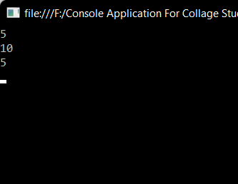

Explicit keyword

using System;

using System.Collections.Generic;

using System.Linq;

using System.Text;

namespace _10.Explicit

{

class apartment

{

public string Name { get; set; }

public static explicit operator House(apartment a)

{

return new House() { Name = a.Name };

}

}

class House

{

public string Name { get; set; }

public static explicit operator apartment(House h)

{

return new apartment() { Name = h.Name };

}

}

class Program

{

static void Main(string[] args)

{

House h = new House();

h.Name = "........My Sweet Home........";

apartment a = (apartment)h;

Console.WriteLine(a.Name);

Console.ReadLine();

}

}

}

Output :-

